**QS2:** STAR LAWS (Shedding Light on Astronomy) Episode II:  **What is a Year?**Name: _________________________________________________

1. Draw a diagram of the Earth orbiting the Sun.
2. What is a year? ____________________________________________________________________________  
   _________________________________________________________________________________________
3. Approximately how many times has the Earth orbited the Sun since you were born? ____________________
4. Why is a year 365¼ days long? ________________________________________________________________

__________________________________________________________________________________________________________________________________________________________________________________

1. Fill in the table below.

|  |  |  |
| --- | --- | --- |
|  | **Actual Diameter (kilometres, km)** | **Relative Diameter** |
| **Earth** |  | **1** |
| **Sun** |  |  |

With respect to the bottom right cell of the table, this means that the sun is _______________ times wider than the Earth.

1. The Earth is about _________________________________ km from the sun. This is approximately _________ Sun diameters.
2. On a scale model, if the Sun had a diameter of 1 metre, the Earth would have a diameter of ____________________ and it would have to be placed _____________________ from the Sun.
3. Why do we have leap years? _________________________________________________________________  
   ___________________________________________________________________________________________________________________________________________________________________________________________________________________________________________________________________________
4. A circle is divided into 360° and the Earth completes one orbit in 365 days, so, in terms of degrees, the Earth travels about _______ ______________ around the sun every day in its orbit. This equates to a distance of about ____________________________________ kilometres.
5. 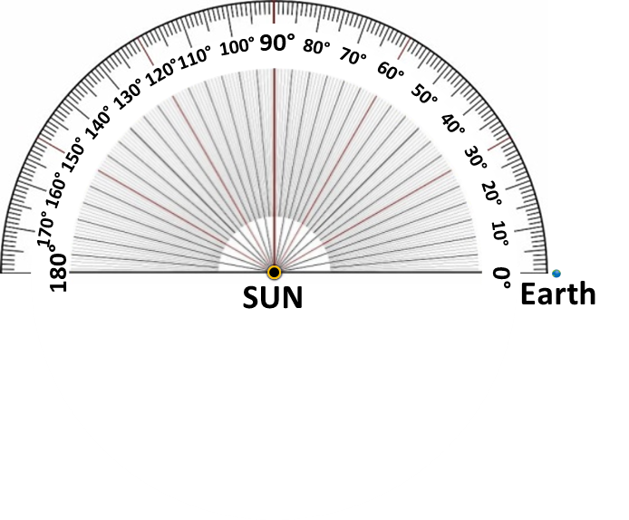 If on a particular day, the earth is in the position shown below right, mark in and label its approximate position…  
   (a) 7 days later,   
   (b) 6 weeks later  
   (c) 3 months (90 days) later, and  
   (d) 6 months later.
6. AD stands for ___________ ______________ which means ______________________________________  
   ____________________________________________  
   BC stands for ___________ ______________  
   CE stands for _________________ ________________